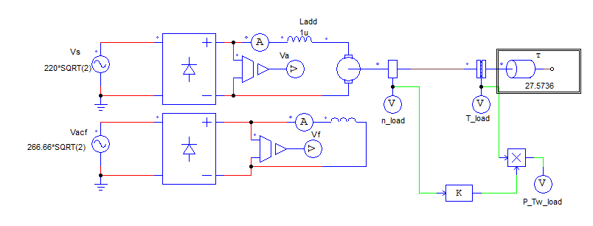

Figura 1 - Circuito utilizado.

II.A) Sistema de Acionamento considerando emprego de retificadores monofásicos de onda completa não controlados

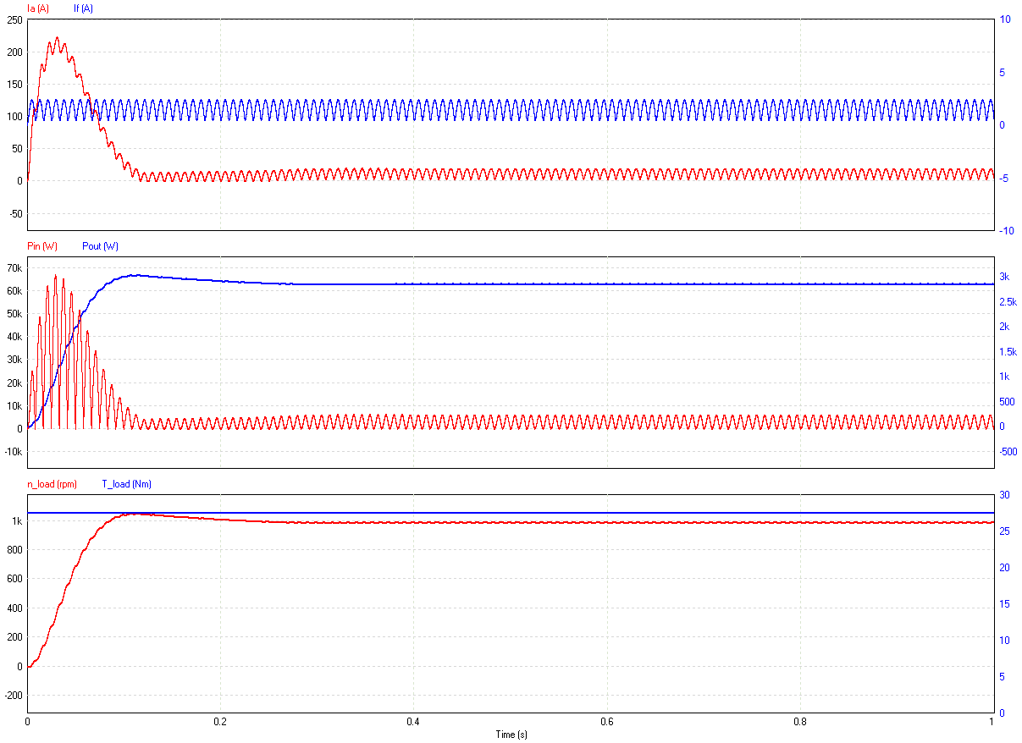

Gráfico 1 - conjugado de carga nominal (100%) e Ladd=1μH.

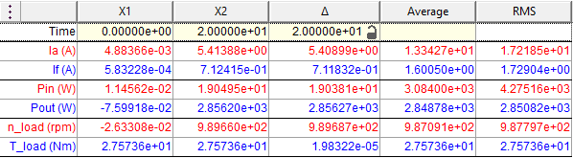

|  |  |  |  |
| --- | --- | --- | --- |
| *Propriedade* | *Média* | *RMS* | *Pico a pico* |
| *Ia (A)* | 1,334E+01 | 1,721E+01 |  |
| *If (A)* | 1,600E+00 | 1,729E+00 |  |
| *Pin (W)* | 3,084E+03 | 4,275E+03 |  |
| *Pout (W)* | 2,848E+03 | 2,850E+03 |  |

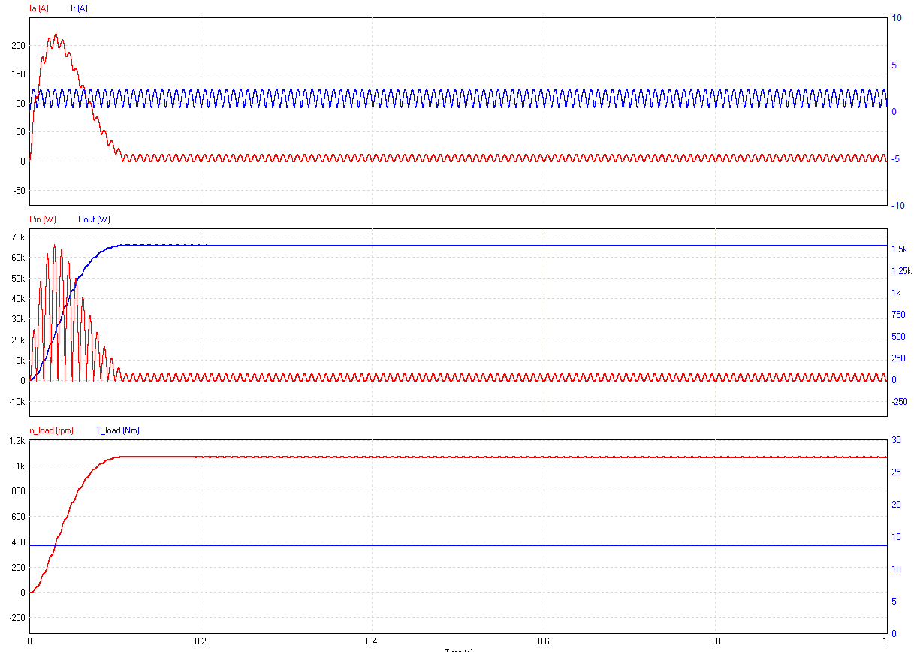

Gráfico 2 - conjugado de carga (50%) e Ladd=1μH.

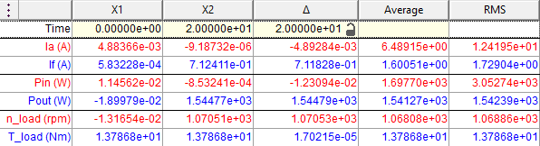

|  |  |  |  |
| --- | --- | --- | --- |
| *Propriedade* | *Média* | *RMS* | *Pico a pico* |
| *Ia (A)* | 6,489E+00 | 1,241E+01 |  |
| *If (A)* | 1,600E+00 | 1,729E+00 |  |
| *Pin (W)* | 1,697E+03 | 3,052E+03 |  |
| *Pout (W)* | 1,541E+03 | 1,542E+03 |  |

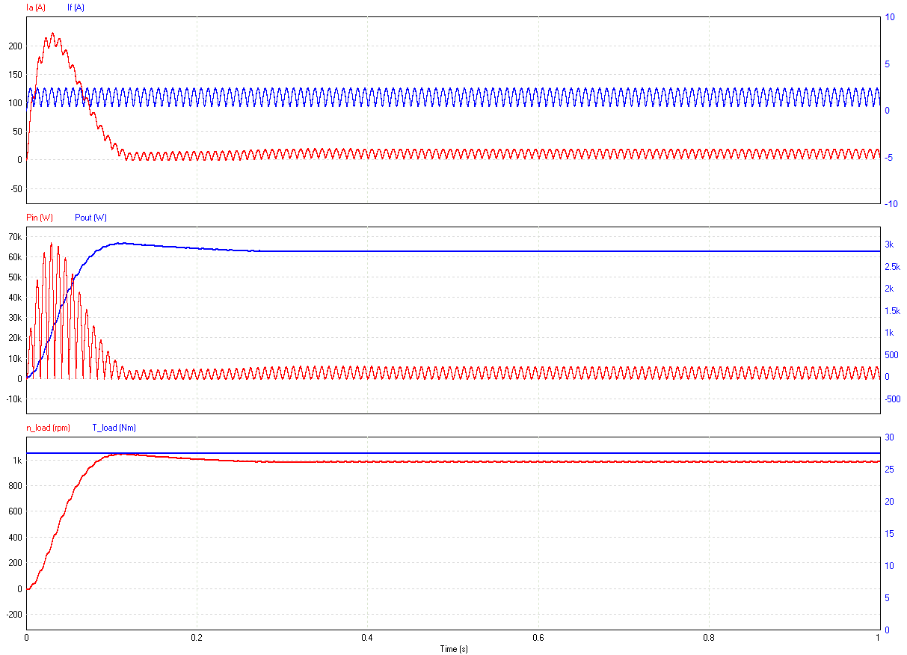

Gráfico 3 - conjugado nominal e Ladd=50mH.

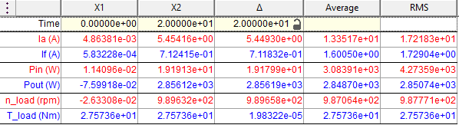

|  |  |  |  |
| --- | --- | --- | --- |
| *Propriedade* | *Média* | *RMS* | *Pico a pico* |
| *Ia (A)* | 1,335E+01 | 1,721E+01 |  |
| *If (A)* | 1,600E+00 | 1,729E+00 |  |
| *Pin (W)* | 3,083E+03 | 4,273E+03 |  |
| *Pout (W)* | 2,848E+03 | 2,850E+03 |  |

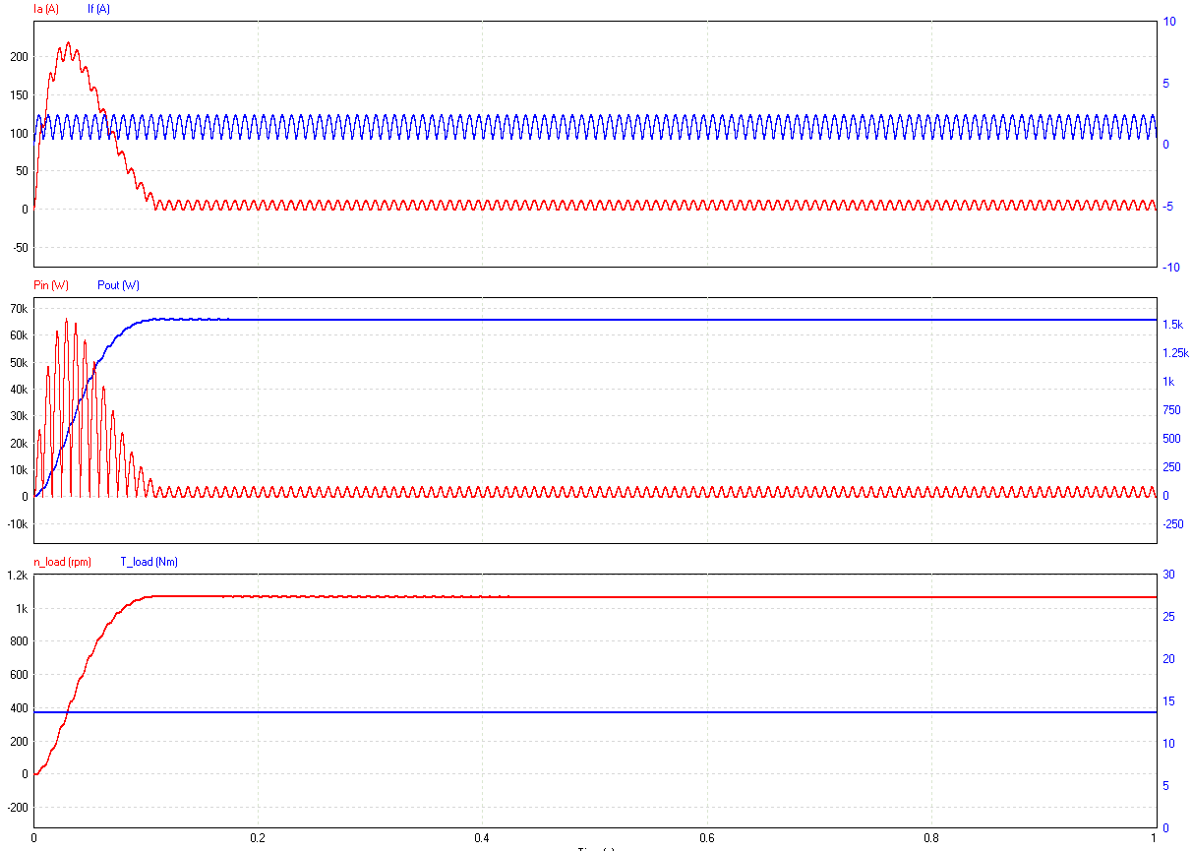

Gráfico 4 - 50% de conjugado de carga e Ladd=50mH.

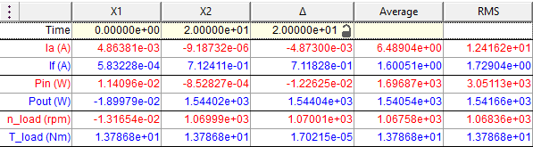

|  |  |  |  |
| --- | --- | --- | --- |
| *Propriedade* | *Média* | *RMS* | *Pico a pico* |
| *Ia (A)* | 6,489E+00 | 1,241E+01 |  |
| *If (A)* | 1,600E+00 | 1,729E+00 |  |
| *Pin (W)* | 1,696E+03 | 3,051E+03 |  |
| *Pout (W)* | 1,540E+03 | 1,541E+03 |  |

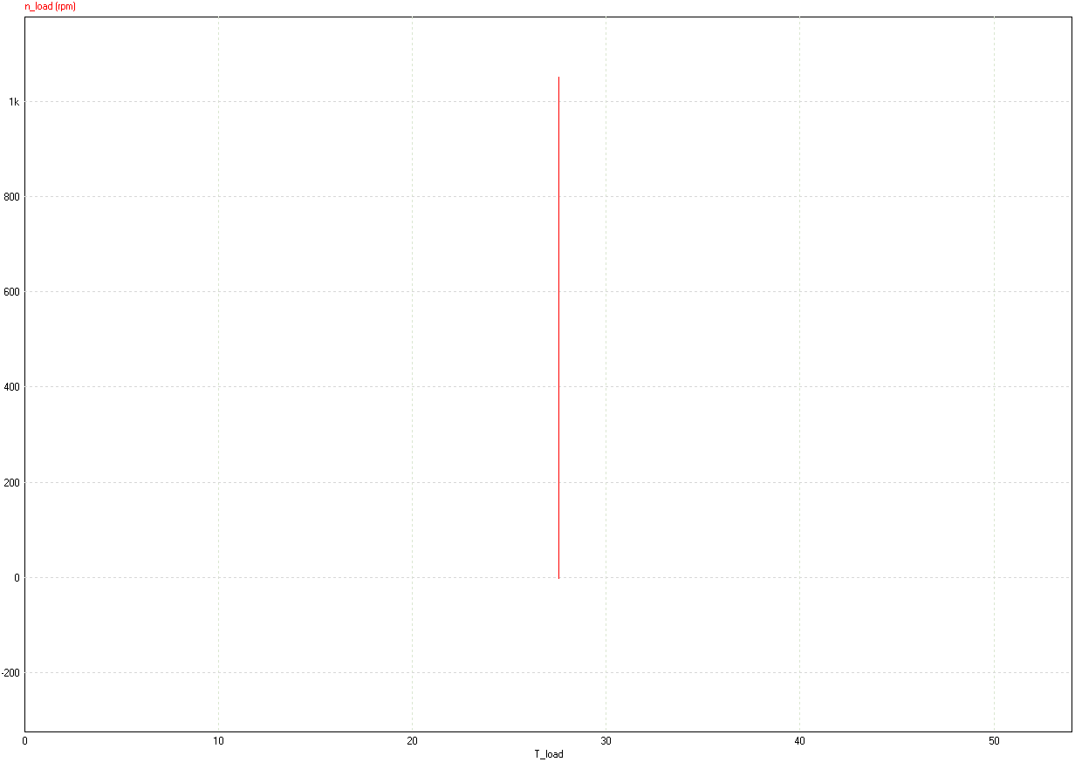

Gráfico 5 - conjugado de carga nominal (100%) para Ladd=1μH e Ladd=50mH.

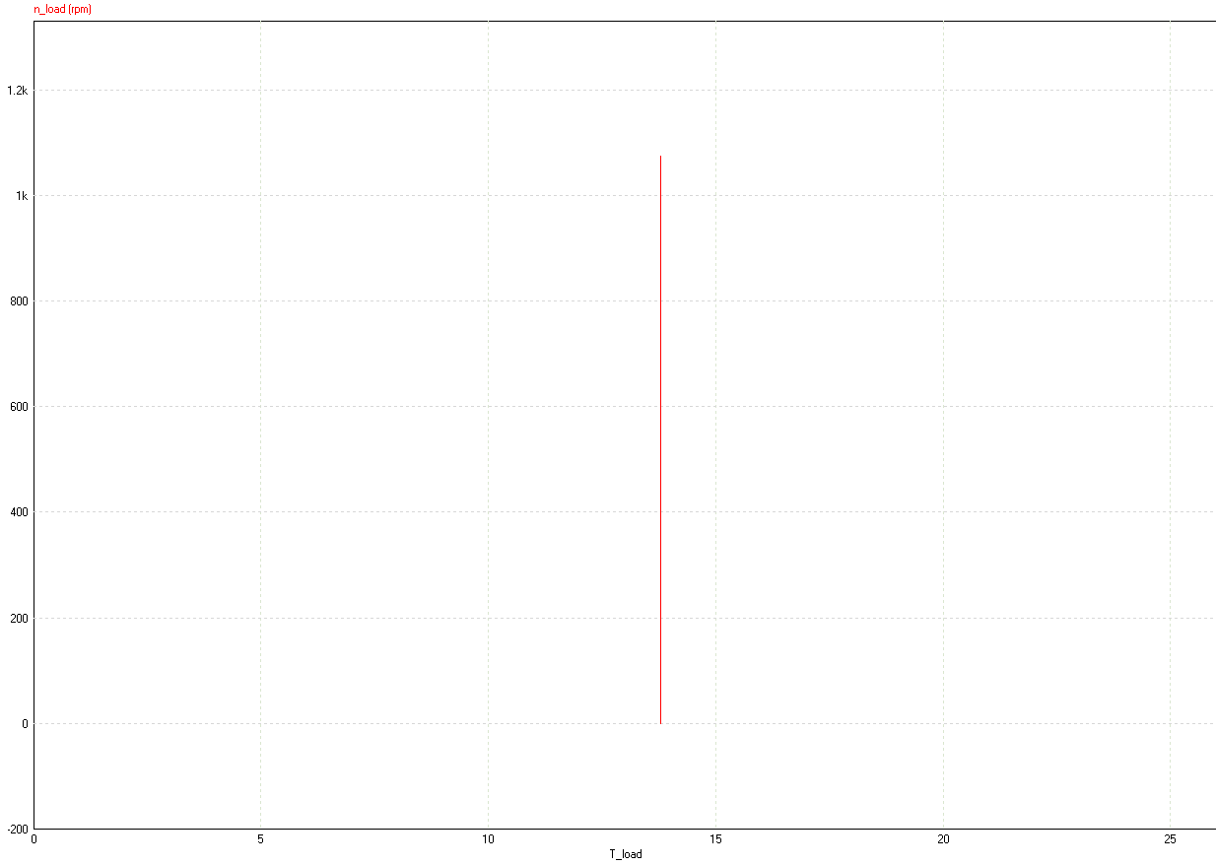

Gráfico 6 - conjugado de carga (50%) para Ladd=1μH e Ladd=50mH.

II.B) Sistema de Acionamento considerando emprego de retificadores monofásicos de onda completa totalmente controlado no circuito de armadura.

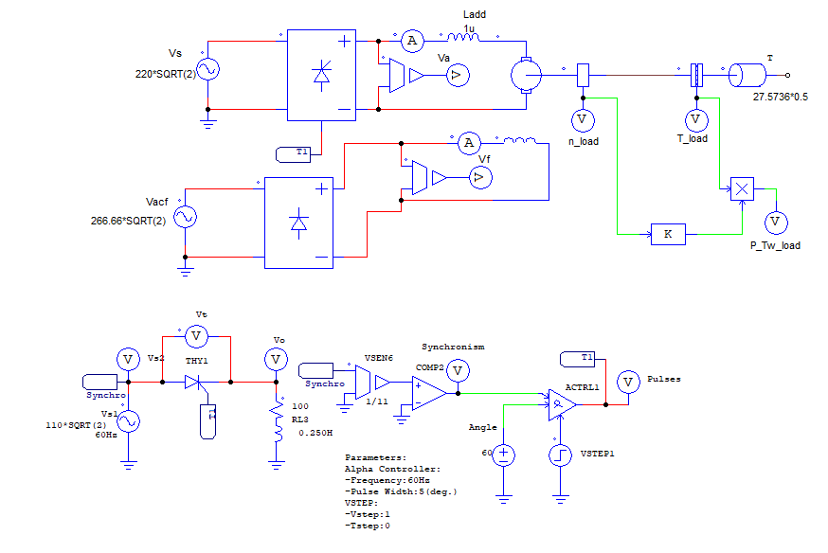

Figura 2 - Circuito utilizado.

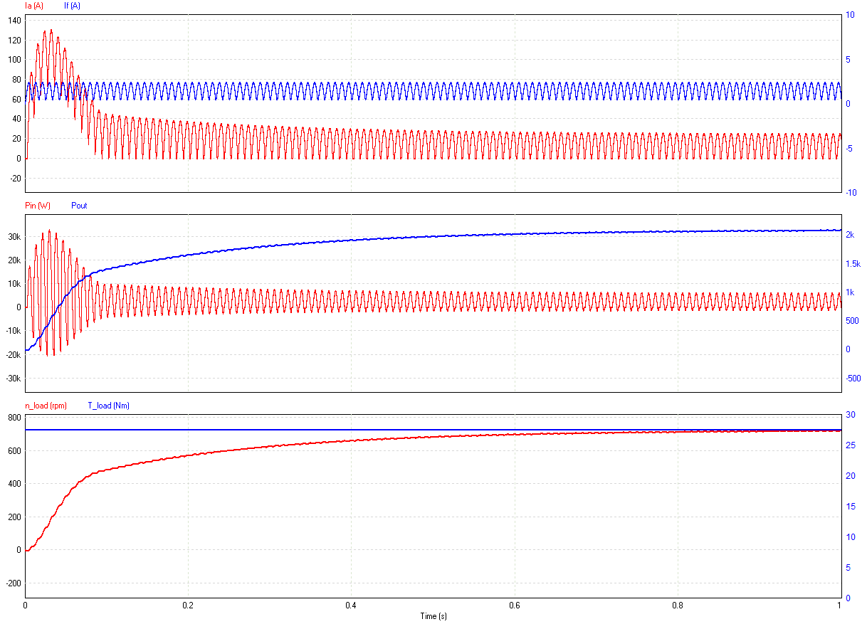

Gráfico 7 - conjugado de carga nominal (100%) e Ladd=1μH.

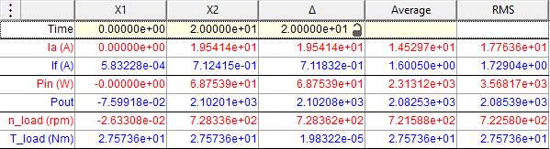

|  |  |  |  |
| --- | --- | --- | --- |
| *Propriedade* | *Média* | *RMS* | *Pico a pico* |
| *Ia (A)* | 1,452E+01 | 1,776E+01 |  |
| *If (A)* | 1,600E+00 | 1,729E+00 |  |
| *Pin (W)* | 2,313E+03 | 3,568E+03 |  |
| *Pout (W)* | 2,082E+03 | 2,085E+03 |  |

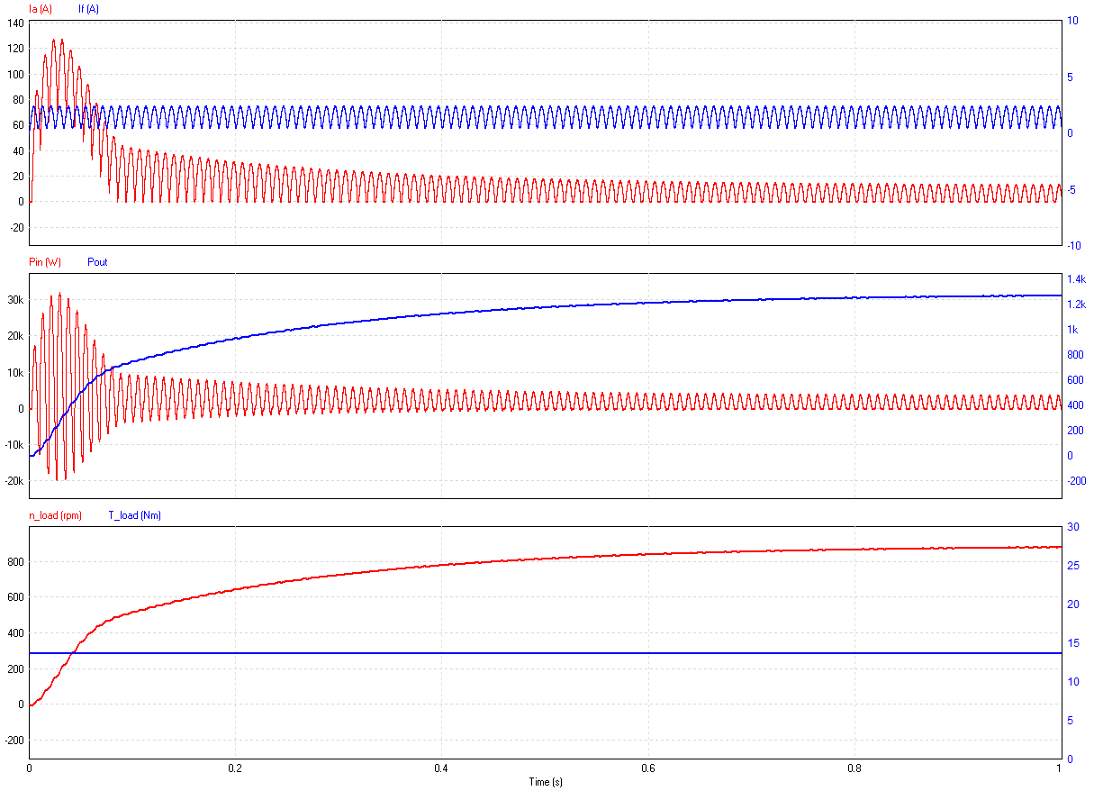

Gráfico 8 - conjugado de carga (50%) para Ladd=1μH.

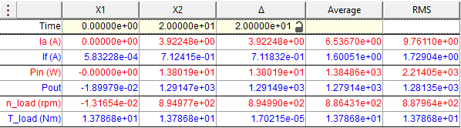

|  |  |  |  |
| --- | --- | --- | --- |
| *Propriedade* | *Média* | *RMS* | *Pico a pico* |
| *Ia (A)* | 6,536E+00 | 9,761E+00 |  |
| *If (A)* | 1,600E+00 | 1,729E+00 |  |
| *Pin (W)* | 1,384E+03 | 2,214E+03 |  |
| *Pout (W)* | 1,279E+03 | 1,281E+03 |  |

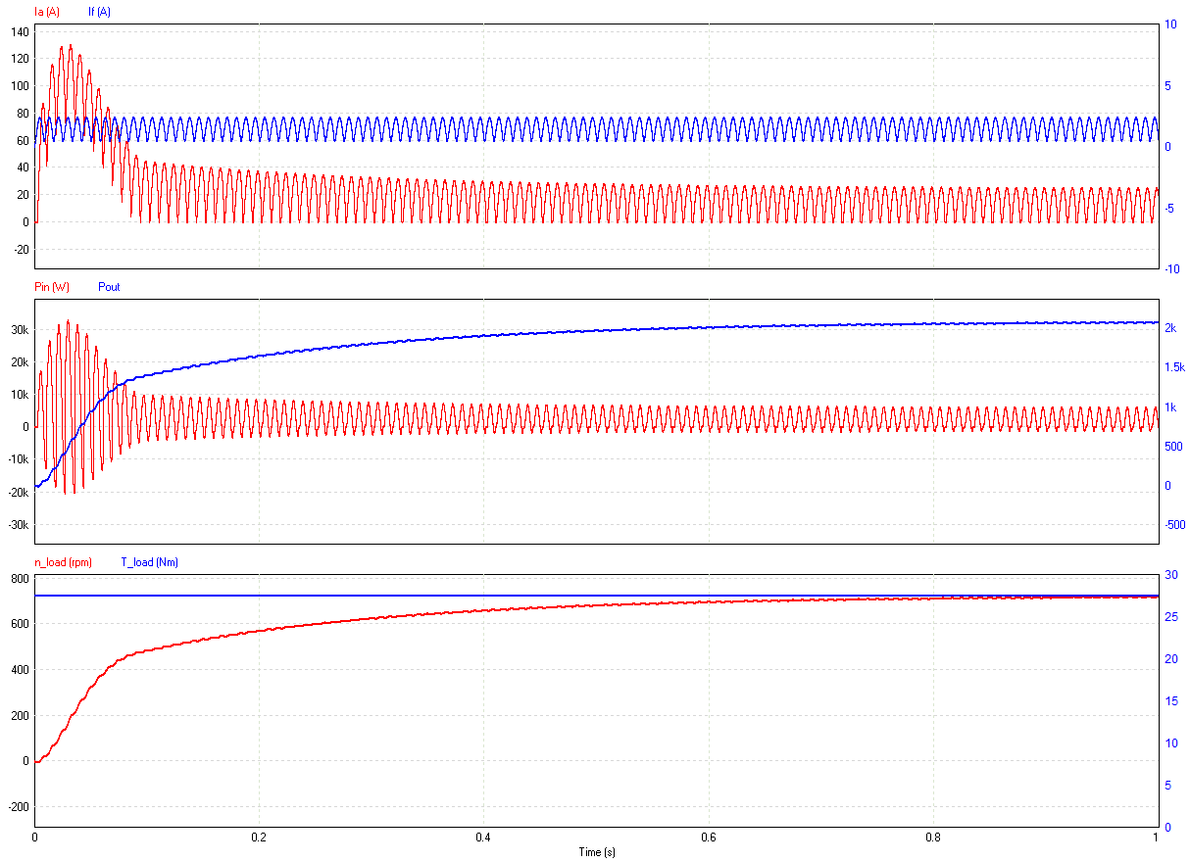

Gráfico 9 - conjugado de carga nominal (100%) Ladd=50mH.

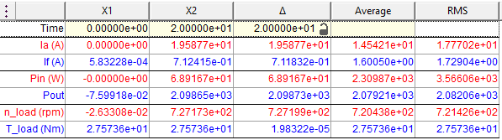

|  |  |  |  |
| --- | --- | --- | --- |
| *Propriedade* | *Média* | *RMS* | *Pico a pico* |
| *Ia (A)* | 1,454E+01 | 1,777E+01 |  |
| *If (A)* | 1,600E+00 | 1,729E+00 |  |
| *Pin (W)* | 2,309E+03 | 3,566E+03 |  |
| *Pout (W)* | 2,079E+03 | 2,082E+03 |  |

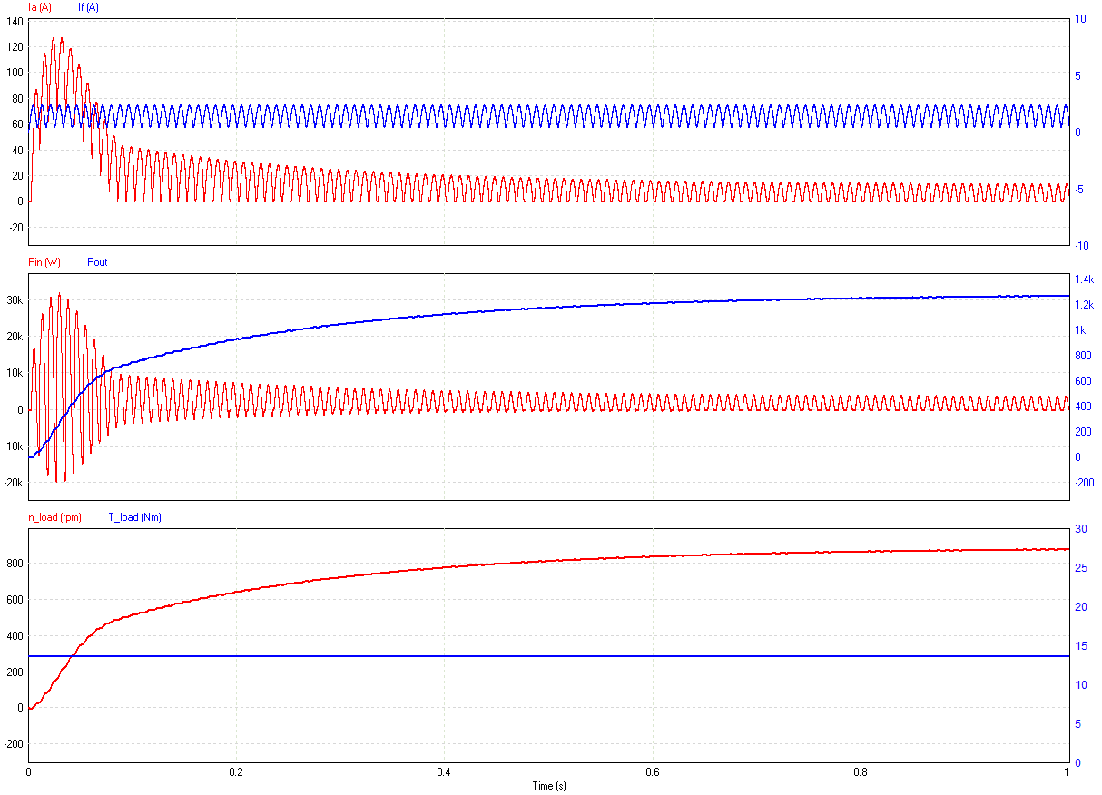

Gráfico 10 - conjugado de carga (50%) para Ladd=50mH.

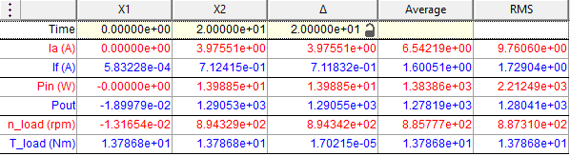

|  |  |  |  |
| --- | --- | --- | --- |
| *Propriedade* | *Média* | *RMS* | *Pico a pico* |
| *Ia (A)* | 6,542E+00 | 9,760E+00 |  |
| *If (A)* | 1,600E+00 | 1,729E+00 |  |
| *Pin (W)* | 1,383E+03 | 2,212E+03 |  |
| *Pout (W)* | 1,278E+03 | 1,280E+03 |  |

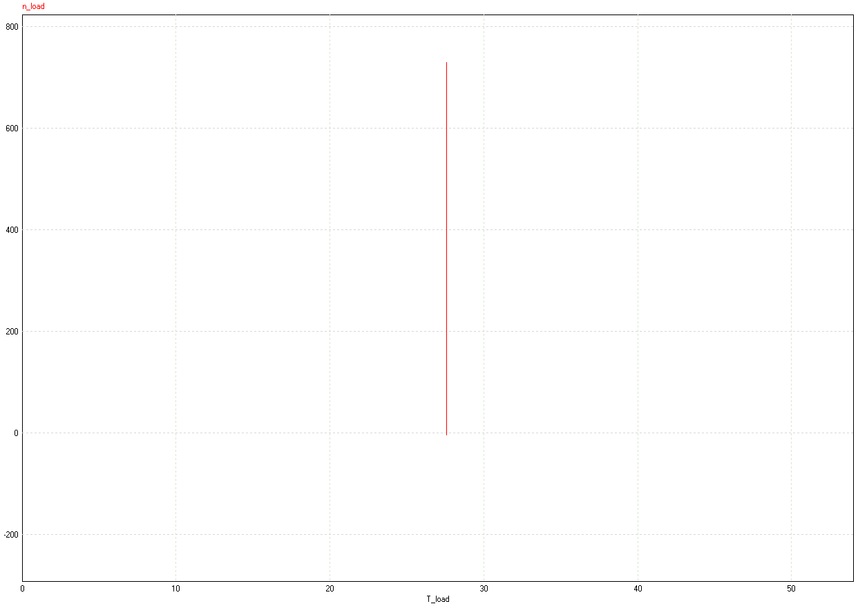

Gráfico 11 - conjugado de carga nominal (100%) para Ladd=1μH e Ladd=50mH.

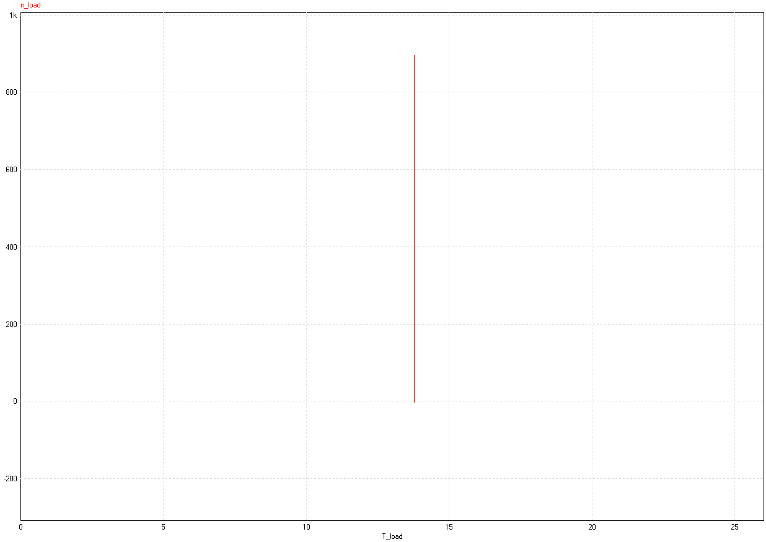

Figura 3 - conjugado de carga (50%) para Ladd=1μH e Ladd=50mH.